**Goal:**

Create an app that monitors sound levels and sends notifications if user volume crosses threshold. And also displays the volume that the user is making for easy monitoring.

**User Story Task Planning:**

As a user, I want to be notified when I am being too loud so that I don’t disturb anyone.

* Create a barebones mobile app
* Receive data from microphone
* Adding UI elements to app
* Send notification once microphone data reaches threshold

Total for above user story: 10 hours

As a user, I want to see how loud I am so that I can put the decibel values into perspective.

* Add an element to display the volume that the microphone is detecting

Total for above user story: 2 hours

**Roles:**

Abdullah Al-Omar: Scrum Master, Developer

John Leckrone: Developer

Akihiro Mizusawa: Developer

Jiying Qi: Product Owner, Developer

Vincent Thai: Developer

**Initial Task Assignment:**

Abdullah Al-Omari: Add an element to display the volume that the microphone is detecting

John Leckrone: Adding UI elements to app

Akihiro Mizusawa: Create a barebones mobile app

Jiying Qi: Receive data from microphone

Vincent Thai: Send notification once microphone data reaches threshold

**Initial burnup chart:** 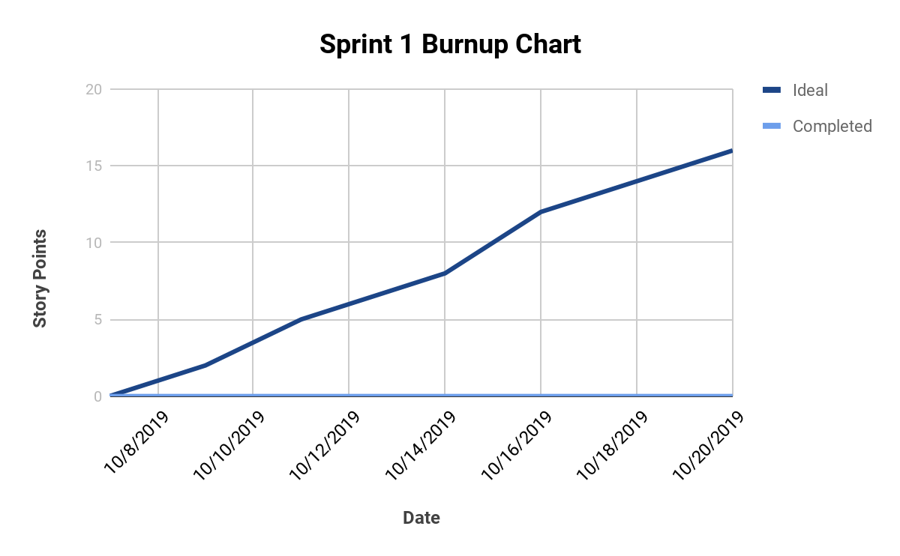

**Scrum times:**